IS 340 – Operating Systems

**HP01A: Cloud Computing Environment - EC2 Instance**

06/04/2019 Developed by Kevin Wang

6/29/2019 reviewed by Clark Jason Ngo & Sam Chung

Center for Information Assurance Education (CIAE) @City University of Seattle (CityU)

|  |  |  |  |  |
| --- | --- | --- | --- | --- |
| C:\Users\chungsam\AppData\Local\Microsoft\Windows\INetCache\Content.MSO\8B8D13C6.tmp | Related image | Image result for OpenSSH | C:\Users\chungsam\AppData\Local\Microsoft\Windows\INetCache\Content.MSO\1E99F4B1.tmp | Image result for Ubuntu |

**Learning Outcomes**

* Registering an AWS account
* Creating an EC2 Ubuntu instance on AWS
* Accessing your Amazon EC2 instance through command line
* Making a secure connection with Windows “OpenSSH Client (Beta)” Setting (optional)
* Making a secure connection with PuTTY (optional)

**Registering an AWS account**

1. Visit <https://aws.amazon.com/>

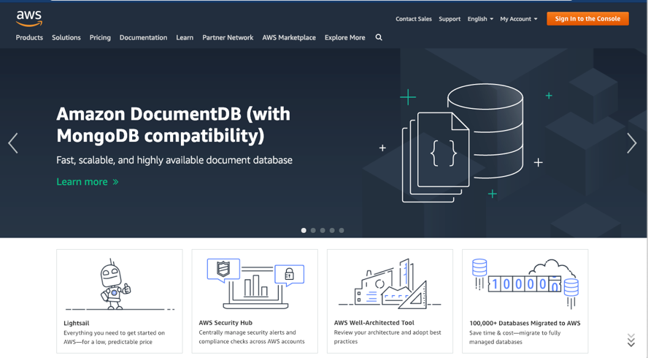

1. If you already created your AWS Account, go to the step 6.   
   Otherwise, click “Create an AWS Account” button on the top-right corner.



1. Fill out the form (use your own information) and click the “Continue” button.

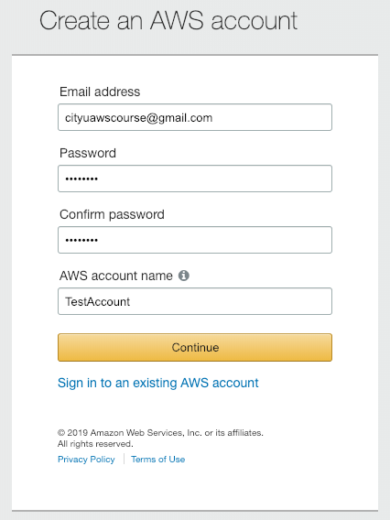

1. Fill out the Account type form and click the “Create Account and Continue” button.

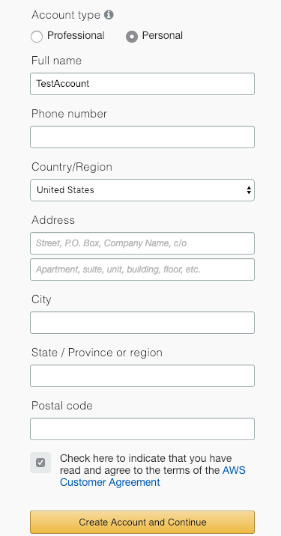

1. Fill out the Payment Information form. (**You will not be charged since AWS offers a one-year free tier. All AWS services that we’ll be using are included in the free tier. But, you are required to check your account carefully.**)

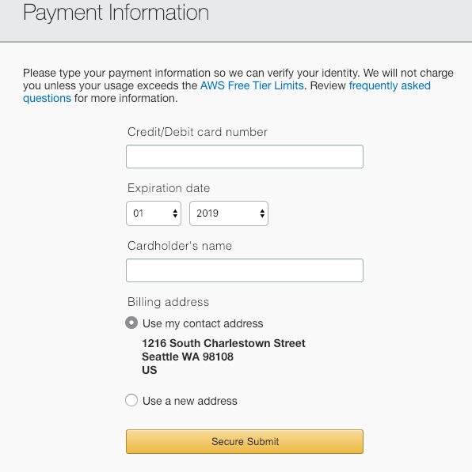

1. After making your account, “Sign in to the Console.”

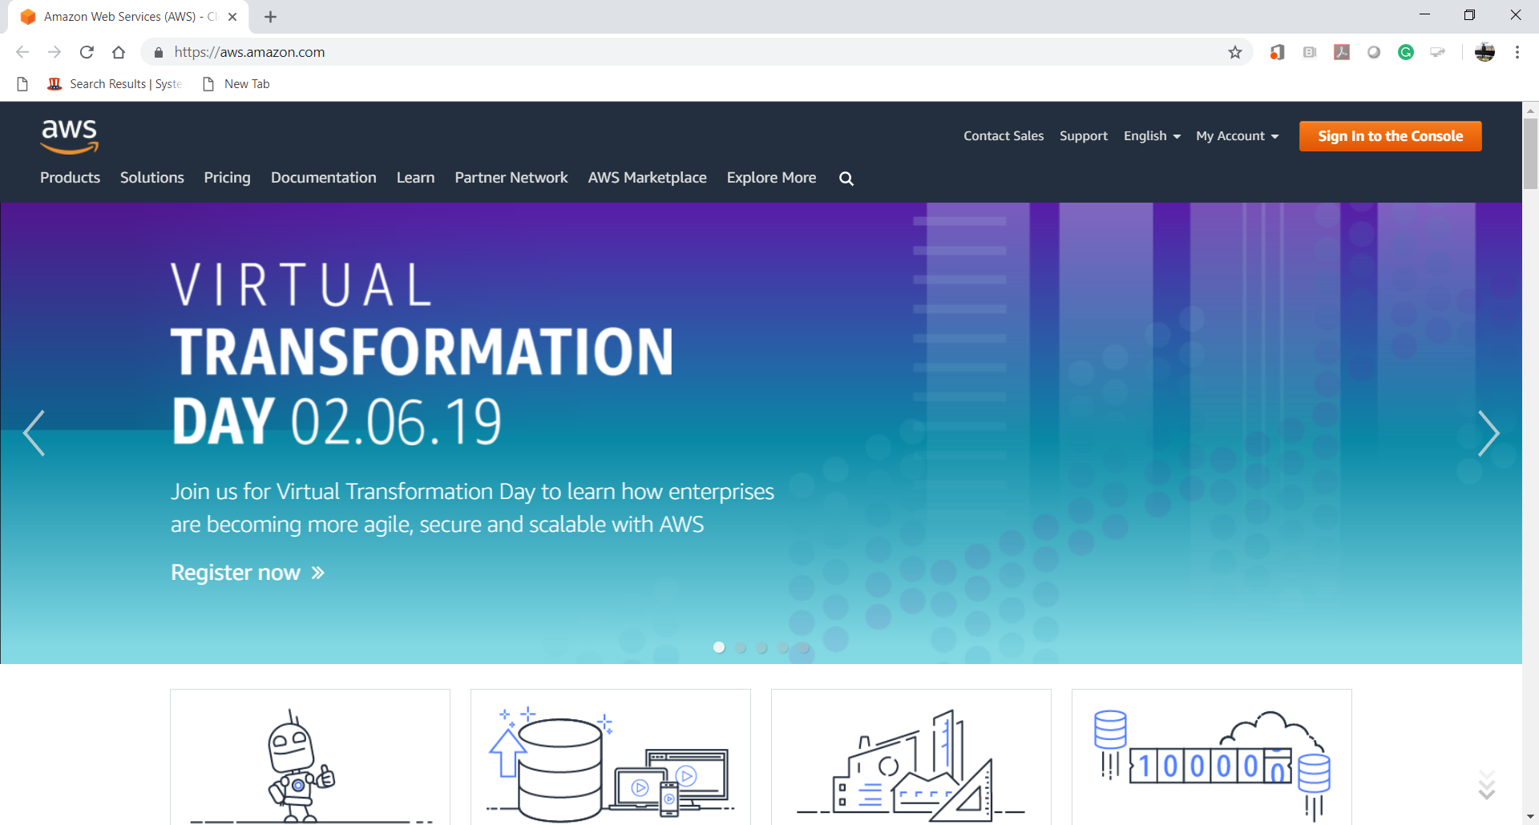

1. Explore “AWS Management Console.”

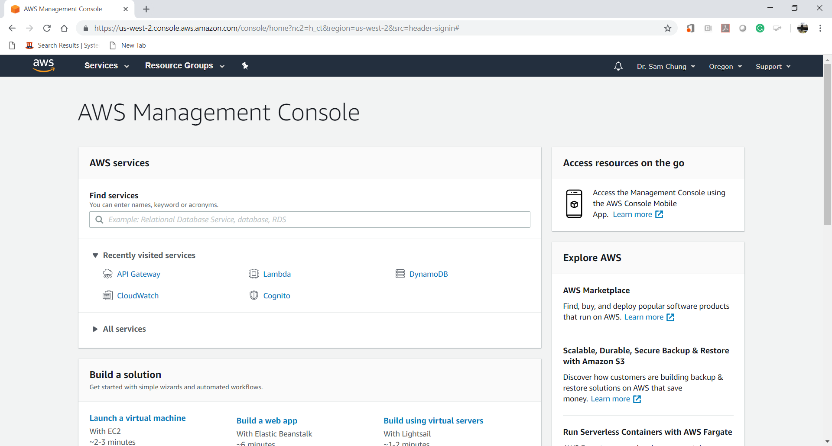

**Creating an EC2 Ubuntu instance on AWS**

1. Type “EC2” in the Find service search bar and click the EC2 keyword from the result.

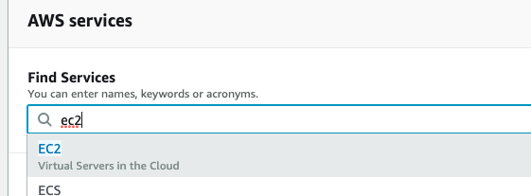

1. Click the Instance from the left menu.

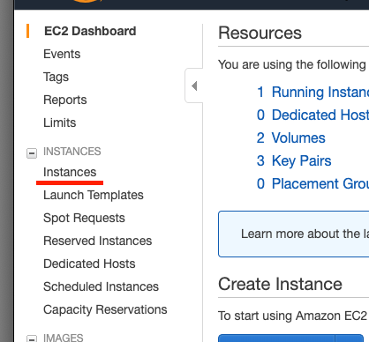

1. Click the “Launch Instance” button and click the “Launch Instance” option from the sub menu.

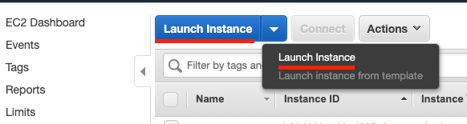

1. Scroll down in the “Choose Amazon Machine Interface (AMI)” section to find “Ubuntu Server 18.04 LTS” image and click “Select” button. (64-bit (xb8) option should be selected).

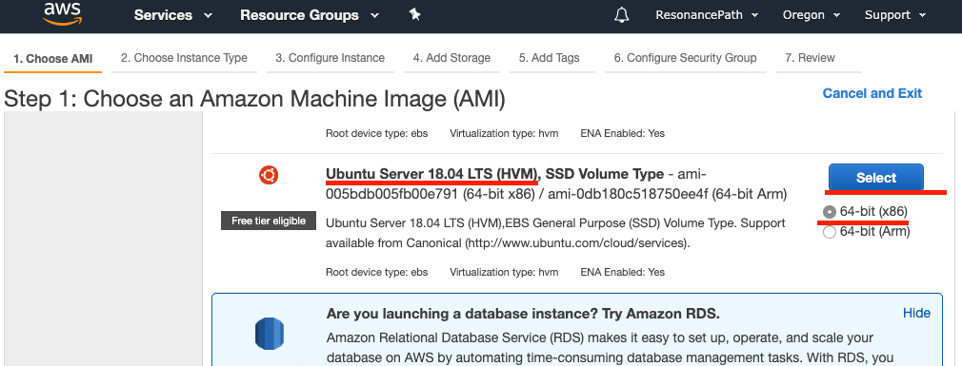  
LTS: Long-Term Support  
HVM: Hardware Virtual Machine

SSD: Solid State Drives  
EBS: Elastic Block Store

1. Choose the “General purpose” “t2.micro” instance and click the “Review and Launch” button in the bottom.

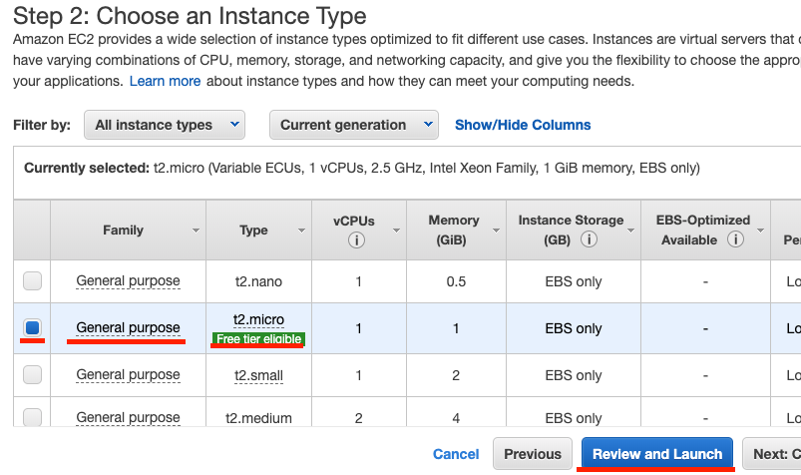

1. In this “Review Instance Launch” section, you can review all default configuration for the new instance. Click the “Launch” button on the bottom of the page after you finish the review.

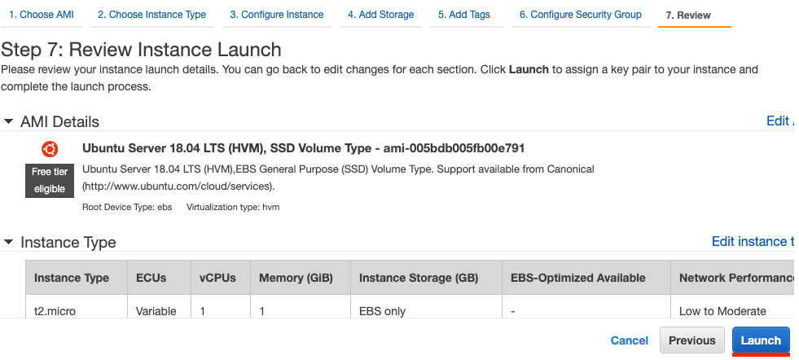

1. Select “Create a new key pair” and type **your key pair name** under it.   
   Click “Download Key Pair” button to save the key to your hard drive.  
   A Privacy Enhanced Mail (PEM) file is downloaded. (You will need it in the future. So, you must remember where you stored. In this case, I created a course directory called “ap301” under the root directory.)

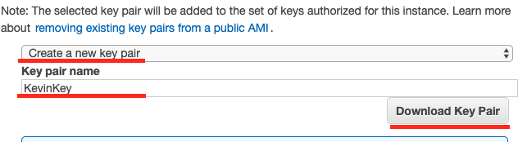

1. After saving the key, click the “Launch Instances” button at the same page.

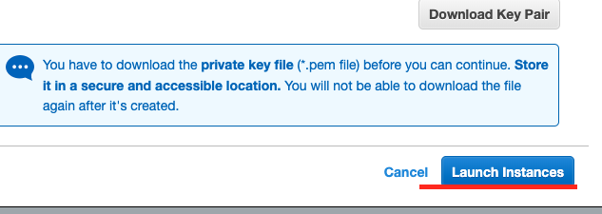

1. You will see the Launch Status. Click the instance id, which is different from the example shown.

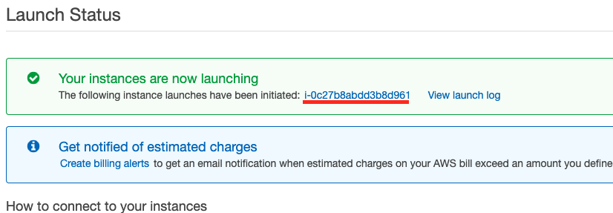

At this page, wait the Status Checks changes to 2/2 checks passed (You can click the refresh button to refresh the status). The two checks are: 1) System Reachability Check, which confirms that AWS is able to get the network packets to the user’s instance. 2) Instance Status Check, which detects a problem within the EC2 instance.

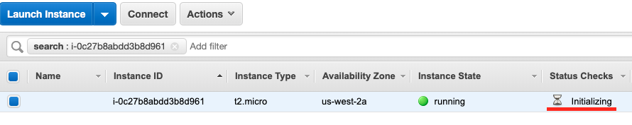

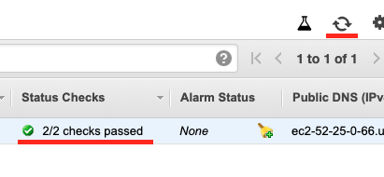

1. Check and copy the public Domain Name System (DNS) from the console (Click the small copy icon).

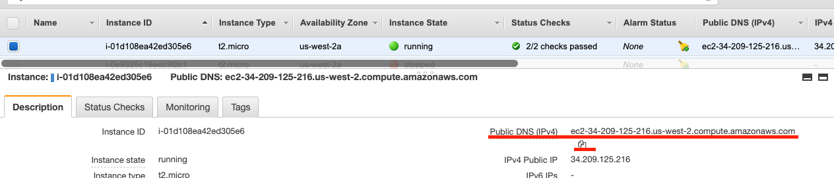

**Accessing your EC2 instance through command line**

1. Open a terminal
   1. Windows OS: press keys “win + r” and type ‘cmd’ and then the enter key.  
      

* 1. Mac OS: press keys “command + space” and type “terminal” and push enter key.  
     

You will get a terminal window likes this:

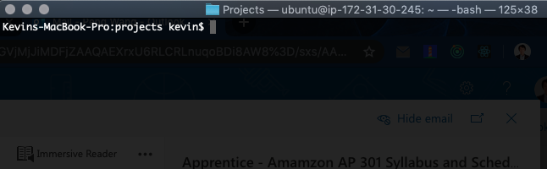

1. Use the command “ssh -i yourKey ubuntu@yourDNS” to connect to the instance

Replace the yourKey with the path and file name you download from the 7th step in the last section and replace the yourDNS from the 10th step in the last section.  
SSH: Secure SHell

One example 

1. Press the enter key and you will see the greeting message from your remoted server.  
   If you cannot execute the SSH command, you need to set up a secure connection first.

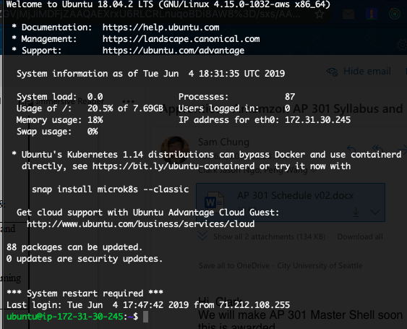

**Making a secure connection with Windows “OpenSSH Client (Beta)” Setting**

**(Please skip this section if you can finish the last section and connect to your EC2 instance)**

1. If you are a Windows user and do not have SSH installed, click “windows” startup button and select “Settings” menu.

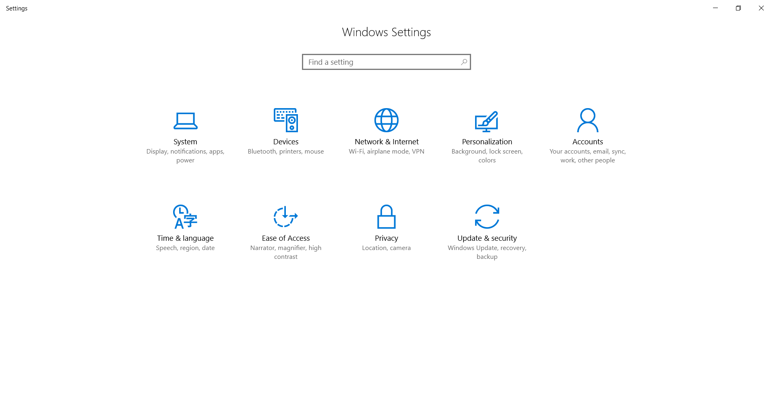

1. Click “System> Apps” and click “Manage optional features” under “Apps & features.”

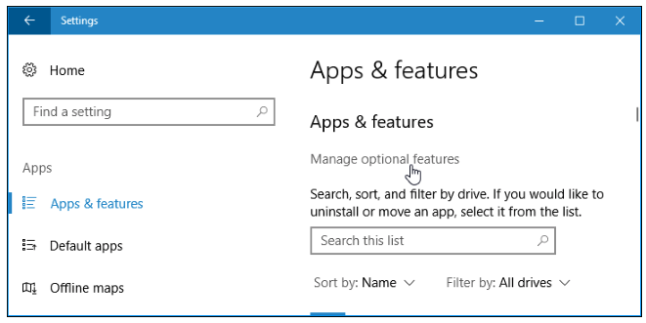

1. Click Add a feature button.  
     
   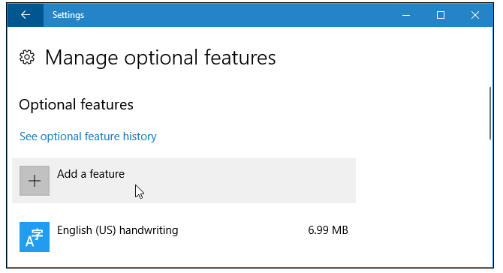
2. Click the “OpenSSH Client (Beta)” option and click “Install.”  
   Notice: Some companies may not allow this “OpenSSH Client” installation.  
   If so, use “PuTTY” in the next section.

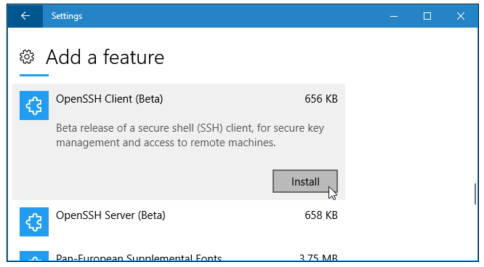

**Making a secure connection with PuTTY**

**(This is the alternative way to connect to EC2 with a GUI software for Windows users.)**

1. Watch the following video first – “How to connect to EC2 w/ PuTTY (Windows)t <https://www.youtube.com/watch?v=bi7ow5NGC-U> (4:18).

[](https://www.youtube.com/watch?v=bi7ow5NGC-U)

1. Download PuTTY.
   1. Visit putty.org.
   2. Click “Download PuTTY” at <https://www.chiark.greenend.org.uk/~sgtatham/putty/latest.html>

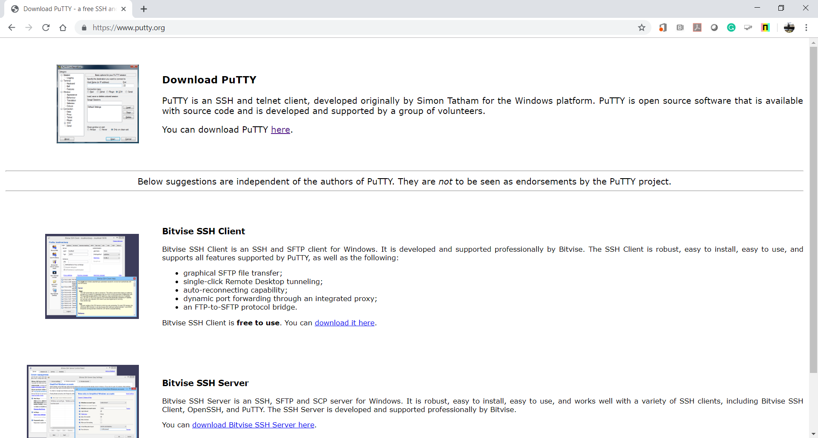

* 1. Download “putty.exe” and “puttygen.exe” for your 64-bit machine.

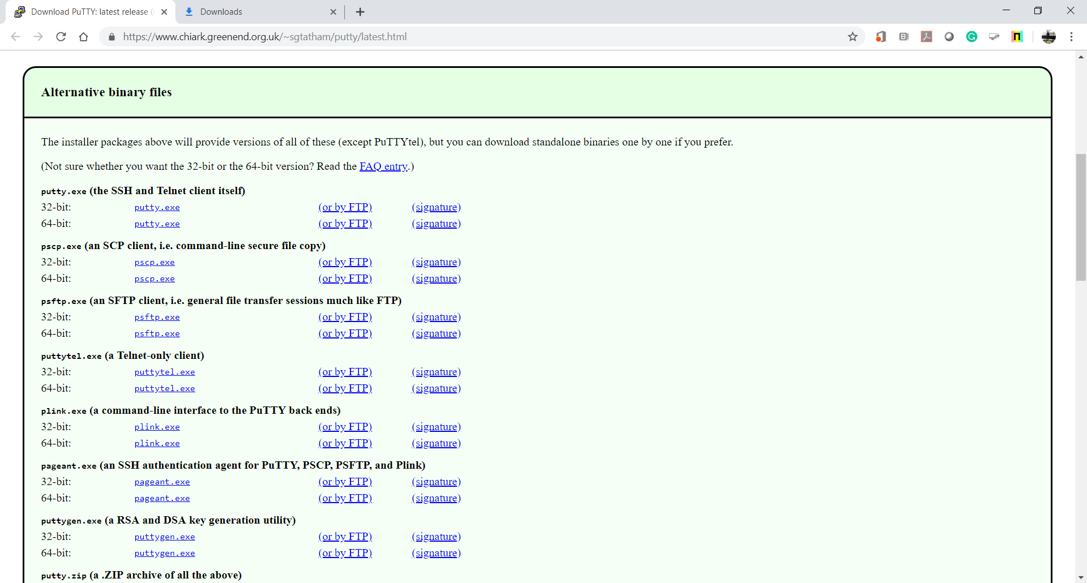

* 1. Store two exe files under the directory that you stored your Privacy Enhanced Mail (PEM) file.

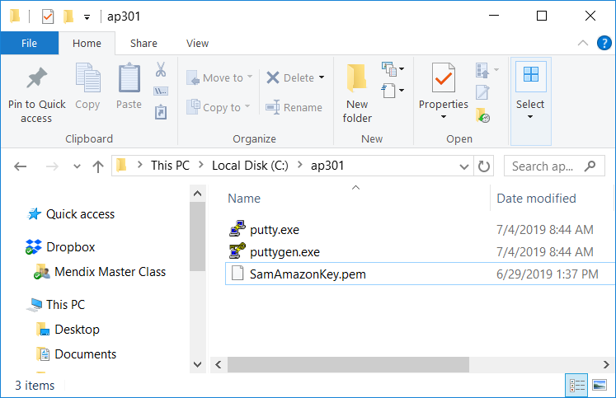

1. Generate PuTTY private key from the given PEM by executing Install “puttygen.exe.”
   1. Load the PEM file to generate public and private key in RSA (Rivest–Shamir–Adleman).

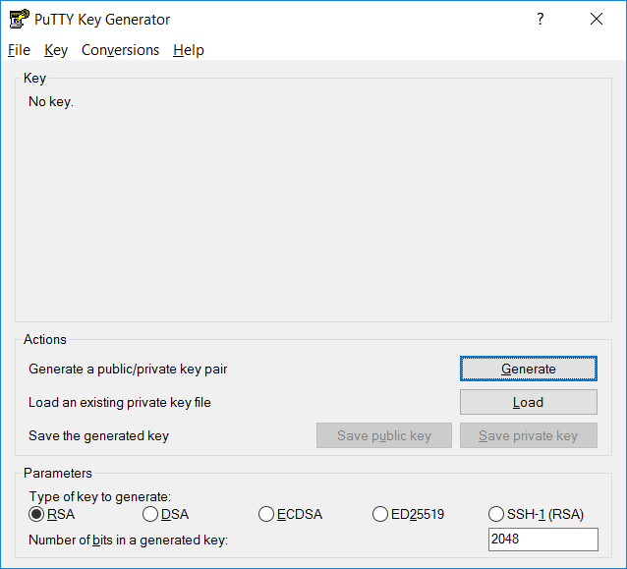

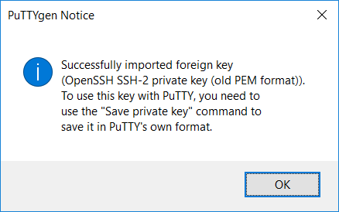

* 1. Save the Putty private key.

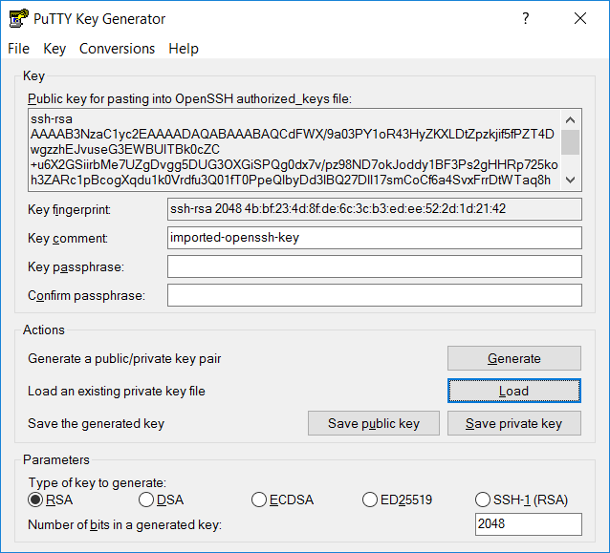

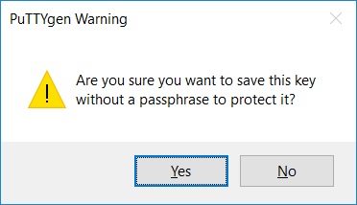

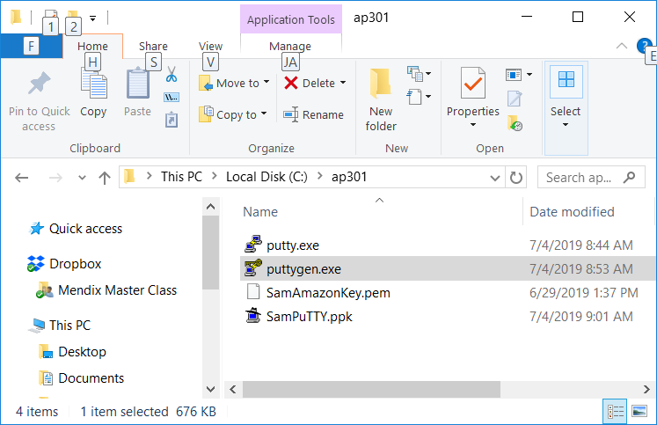

* 1. Close the PuTTY Key Generator.

1. Find your Amazon EC2 host name and user name in addition to the given PuTTY Private Key (PPK).
   1. Select your amazon EC2 instance and then press the “Connect” tab.
   2. You can find your user name before @ and host name after @. For example, your EC2 user name is “Ubuntu” and host name is “54.191.75.107”

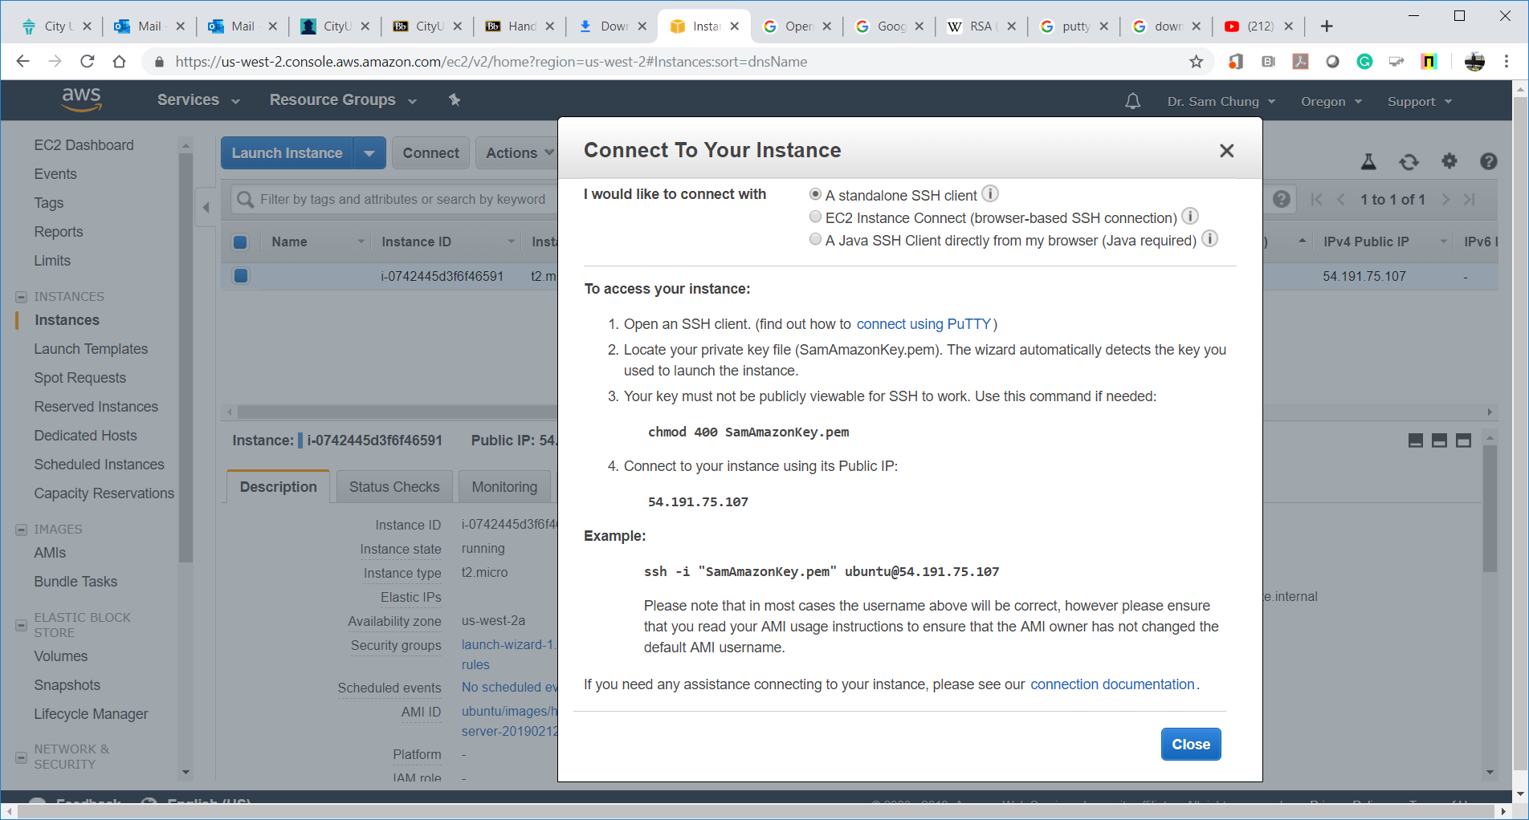

1. Configure PuTTY connection to your Amazon EC2 with the known host, user name, and PPK.
   1. Execute the “putty.exe.”
   2. Enter the host name.

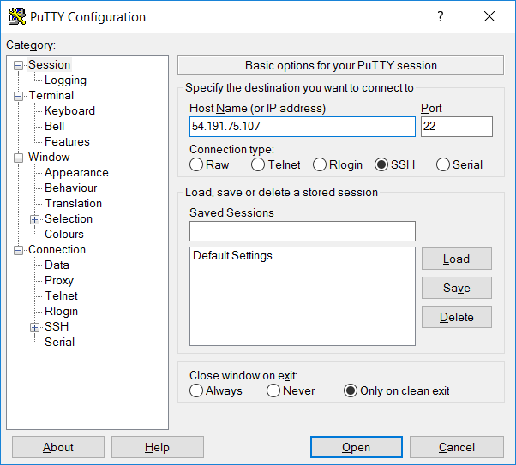

* 1. Select “Connection>>Data” and enter your user name.

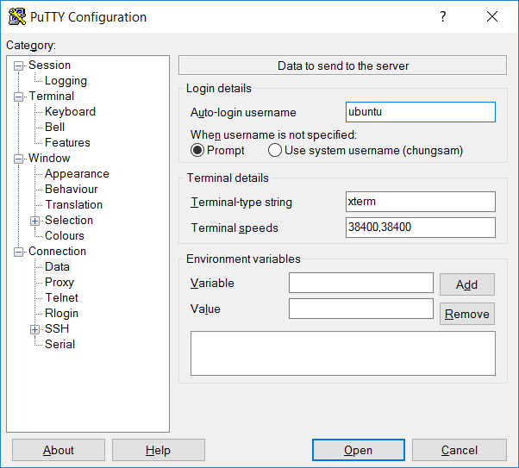

* 1. Select “Connection>>SSH>>Auth” and load your PPK.

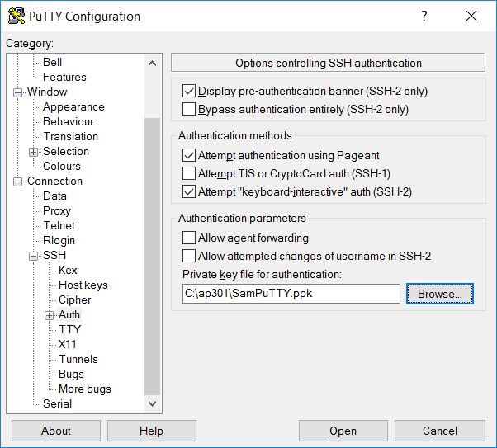

* 1. Save this session with a name like “SamEC2” (Use your first name.)  
     Press “Session” and enter your session name.
  2. Open your connection.

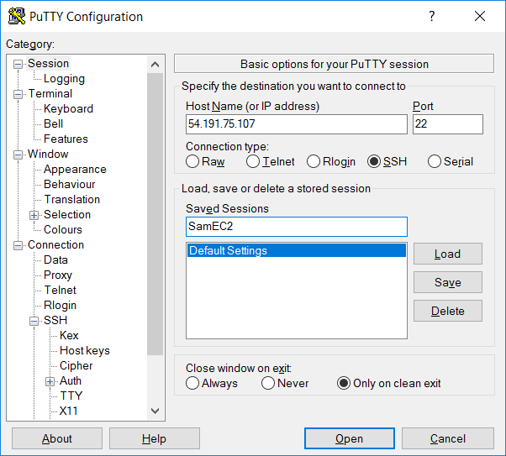

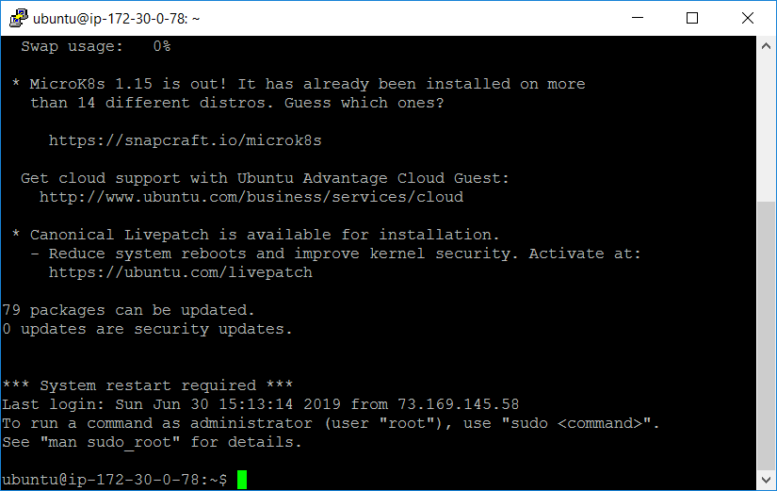

* 1. Close the session.

1. Connect to EC2 with your predefined session again.
   1. Execute the “putty.exe” again.
   2. Select the predefined session and open it.

